# [ADD THE FOLLOWING CSS classes](onenote:Sprint2a%20Changes.one" \l "ADD%20CSS%20classes&section-id=%7B75FB6649-27A7-4C98-ABA1-F156DF624D14%7D&page-id=%7B6F2B6F2F-184D-4B89-AB99-FF296C77F557%7D&object-id=%7BDE6BEC64-A7CA-4CD2-82D7-980987D051C4%7D&25&base-path=https://d.docs.live.net/754eedc13da6ddbe/%5e.Documents/GlobalCla) to stratus.css

ADD THE FOLLOWING CSS classes

/*** used for Burr to space stuff out****/

.content_spacer_10px

{

margin-top: 10px;

margin-bottom: 10px;

}

.content_spacer_20px

{

margin-top: 20px;

margin-bottom: 20px;

}

.content_spacer_30px

{

margin-top: 30px;

margin-bottom: 30px;

}

.content_spacer_40px

{

margin-top: 40px;

margin-bottom: 40px;

}

================================================================

# [Change the page <h1> for titles to use the](onenote:Sprint2a%20Changes.one#Page%20titles&section-id=%7B75FB6649-27A7-4C98-ABA1-F156DF624D14%7D&page-id=%7B81B1D6ED-2F7E-49B9-930D-AFEE5374C0DE%7D&object-id=%7B1317A060-B50F-43A6-83C2-18AC433EF4B4%7D&22&base-path=https://d.docs.live.net/754eedc13da6ddbe/%5e.Documents/GlobalClassroom) new CSS for 20px (see ["Example spacing"](onenote:Sprint2a%20Changes.one#Example%20spacing&section-id=%7B75FB6649-27A7-4C98-ABA1-F156DF624D14%7D&page-id=%7B5854F6DD-EC25-4968-A94F-4467BC0534D3%7D&object-id=%7BCE01E649-868E-4D92-A1EA-57B26209DC14%7D&22&base-path=https://d.docs.live.net/754eedc13da6ddbe/%5e.Documents/GlobalClass) )

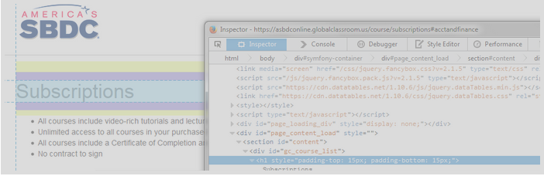

Change the page <h1> for titles to use the new CSS class "content_spacer_20px"

See [ADD THE FOLLOWING CSS classes](onenote:#ADD%20CSS%20classes&section-id=%7B75FB6649-27A7-4C98-ABA1-F156DF624D14%7D&page-id=%7B6F2B6F2F-184D-4B89-AB99-FF296C77F557%7D&object-id=%7BDE6BEC64-A7CA-4CD2-82D7-980987D051C4%7D&25&base-path=https://d.docs.live.net/754eedc13da6ddbe/%5e.Documents/GlobalCla)

==================================

# 3.[Change the 'my free and paid subscriptions <h2](onenote:Sprint2a%20Changes.one#My%20free%20and%20paid%20titles&section-id=%7B75FB6649-27A7-4C98-ABA1-F156DF624D14%7D&page-id=%7BC7F55583-E113-4057-8185-5A42E5146E29%7D&object-id=%7B9C7D7A6B-B2F5-4B87-9CF0-8EC587DA9209%7D&20&base-path=https://d.docs.live.net/754eedc13da6ddbe/%5e.Documen)> to use the CSS for 20PX (see ["Example spacing"](onenote:Sprint2a%20Changes.one#Example%20spacing&section-id=%7B75FB6649-27A7-4C98-ABA1-F156DF624D14%7D&page-id=%7B5854F6DD-EC25-4968-A94F-4467BC0534D3%7D&object-id=%7BCE01E649-868E-4D92-A1EA-57B26209DC14%7D&22&base-path=https://d.docs.live.net/754eedc13da6ddbe/%5e.Documents/GlobalClass) )

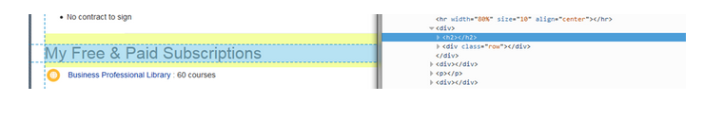

Change the 'my free and paid subscriptions <h2>

See [ADD THE FOLLOWING CSS classes](onenote:#ADD%20CSS%20classes&section-id=%7B75FB6649-27A7-4C98-ABA1-F156DF624D14%7D&page-id=%7B6F2B6F2F-184D-4B89-AB99-FF296C77F557%7D&object-id=%7BDE6BEC64-A7CA-4CD2-82D7-980987D051C4%7D&25&base-path=https://d.docs.live.net/754eedc13da6ddbe/%5e.Documents/GlobalCla)

# 4.[Change the <h2> to use the new 20PX CSS](onenote:Sprint2a%20Changes.one#$10%20titles&section-id=%7B75FB6649-27A7-4C98-ABA1-F156DF624D14%7D&page-id=%7BD26C5301-BCDF-472F-B46B-7899F71CC216%7D&object-id=%7B3920817A-BBE0-4A6E-9626-DE1A99A97B36%7D&22&base-path=https://d.docs.live.net/754eedc13da6ddbe/%5e.Documents/GlobalClassroom) for the $10 and the $20 headers (see ["Example spacing"](onenote:Sprint2a%20Changes.one#Example%20spacing&section-id=%7B75FB6649-27A7-4C98-ABA1-F156DF624D14%7D&page-id=%7B5854F6DD-EC25-4968-A94F-4467BC0534D3%7D&object-id=%7BCE01E649-868E-4D92-A1EA-57B26209DC14%7D&22&base-path=https://d.docs.live.net/754eedc13da6ddbe/%5e.Documents/GlobalClass) )

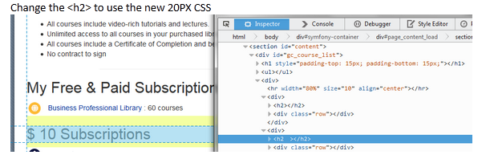

# 5.Subscription page [Remove the bulleted list and replace with the following text](onenote:Sprint2a%20Changes.one#Subscriptions%20page&section-id=%7B75FB6649-27A7-4C98-ABA1-F156DF624D14%7D&page-id=%7B8086F8F1-5787-47D2-9662-8F3DF730EF9C%7D&object-id=%7B5C5AA8B3-AD5F-464E-A2FC-F24102C2DF53%7D&22&base-path=https://d.docs.live.net/754eedc13da6ddbe/%5e.Documents/GlobalCl)

Remove the bulleted list and replace with the following text

<p>Global Classroom's subscription libraries provide members with unlimited access to courses that are focused on the job-relevant skills required to succeed in today's  global economy. All courses completed recognize the member with a Certificate or a Badge of Participation that can be shared with your colleagues and or employer.</p>

# 6.Course Page - [Change the course page and remove the bullets and replace](onenote:Sprint2a%20Changes.one#Courses%20text&section-id=%7B75FB6649-27A7-4C98-ABA1-F156DF624D14%7D&page-id=%7BE43D80D3-06A7-49C2-AA88-5CD4A1E4901A%7D&object-id=%7B8A8E2ACD-9DA8-4556-A374-C5FB3311A85E%7D&22&base-path=https://d.docs.live.net/754eedc13da6ddbe/%5e.Documents/GlobalClassroo) the text

Change the course page and remove the bullets and replace with the following text

<p>Select Courses are available for members to purchase. There's no monthly subscription fee required and members have unlimited access to the course for three months. All courses completed recognize the member with a Certificate or Badge of Participation that can be shared with your colleagues and or employer</p>

# 7.Course Library  - [Remove the bulleted list and replace with the following text](onenote:Sprint2a%20Changes.one#Course%20Libraries&section-id=%7B75FB6649-27A7-4C98-ABA1-F156DF624D14%7D&page-id=%7B0E24D65E-75EB-44D0-AACC-FE5C1DCE17B1%7D&object-id=%7B38986944-B90B-482E-94B3-CC80BC4CB004%7D&25&base-path=https://d.docs.live.net/754eedc13da6ddbe/%5e.Documents/GlobalClas)

Remove the bulleted list and replace with the following text

<p>Global Classroom's Certification Programs recognize members for the completion of an educational program that is focused on a subject area. All Certification Programs include a series of interactive learning modules that include: <b>**video-rich lectures, quizzes & printable guides**</b> to help conceptualize key points and apply learned skills. Many Certifications also prepare members for examinations that are required by the certifying or the accrediting organization. Members have unlimited access to the content of the Certification Program for twelve months. </p>

# 8.Remove the HUBSPOT code in all pages (see [Sample hubspot code](onenote:Sprint2a%20Changes.one#Hubsopt&section-id=%7B75FB6649-27A7-4C98-ABA1-F156DF624D14%7D&page-id=%7B361AD5C2-E079-4F51-A6BD-96B6F7AF702C%7D&object-id=%7BE99563ED-7841-4A72-8EA6-8AE08D70A86A%7D&22&base-path=https://d.docs.live.net/754eedc13da6ddbe/%5e.Documents/GlobalClassroom))

Sample hubspot code

<script type="text/javascript" language="javascript">   
var hs_portalid=108225;   
var hs_salog_version = "2.00";   
var hs_ppa = "globalclassroom.app10.hubspot.com";   
document.write(unescape("%3Cscript src='" + document.location.protocol + "//" + hs_ppa + "/salog.js.aspx' type='text/javascript'%3E%3C/script%3E"));   
</script>

# 9.Make top navigation tabs "dynamic" [Make the tabs dynamic to show and hide the tabs](onenote:Sprint2a%20Changes.one#Top%20tab%20navagation&section-id=%7B75FB6649-27A7-4C98-ABA1-F156DF624D14%7D&page-id=%7B35C470EF-B3F5-49E0-9FE0-2E2326084F7D%7D&object-id=%7B1516AD53-D737-4956-BE10-EAFFB6E74449%7D&36&base-path=https://d.docs.live.net/754eedc13da6ddbe/%5e.Documents/Global)

Make the tabs dynamic to show and hide the tabs approperialy

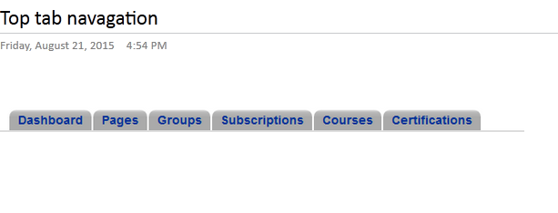

If product_type = 1

Then the subscriptions should show

End if

If product_type = 1

Then the certifications should show

End if

If product_type = 2

Then the courses should show

End if

If product_type = 3

Then the certificationsshould show

End if

==========================

# 10. Fix PayPal response typo

# 11. Fix course page where price = $0

# 12. Change certification images to the new icons